Final Report

The Herger-Feinstein Quincy Library Group Project —Impacts of Vegetation Management on Water Yield

Submitted to

Colin Dillingham
HFQLG Monitoring Team Leader
Vegetation Management Solutions
Forest Service Enterprise Team

Prepared By

C. A. Troendle
METI Corporation
Fort Collins, CO

J. M. Nankervis
Blue Mountain Consultants
Berthoud, CO

A. Peavy
U. S. Forest Service
Fort Collins, CO

Technical Services in Support of Agency-Wide
Ecosystem Management Programs
Contract AG 3187 D 05 0043

The Herger-Feinstein Quincy Library Group Project —Impacts of Vegetation Management on Water Yield

C. A. Troendle, J. M. Nankervis, and A. Peavy
1 May 2007

Introduction

In October 1998, the Herger-Feinstein Quincy Library Group Forest Recovery (HFQLG) Act was signed into law. The Act was developed from the Quincy Library Group's 1993 Community Stability proposal to examine local forest management strategies for reducing forest fuels and the risk of wildfires, promoting forest health, and restoring economic stability to rural communities. The proposal was developed with a desired future condition of an all-age, multi-storied, fire resistant forest approximating pre European settlement conditions.

The HFQLG project proposed treatments to reduce forest density as a primary means of reducing the risk of wildfire and improving forest health. Proposed treatments, usually partial cuts or thinning, will change vegetation structure on 200,000 to 300,000 of almost 2.5 million acres. The project is mandated to address the timing of water releases, water quality changes, and water-yield changes on pilot areas. The preferred Sierra Conservation Framework alternative for the Plumas, Lassen, and Tahoe National Forests includes implementing the Quincy Library Group project for five years and the resulting water-yield changes on these forests are evaluated and discussed in this report.

We proposed the following three alternative approaches to the implementation team to assess the on- and off-site impacts of the proposed vegetation treatments on water yield.

- Develop a white paper based on past research and current hydrologic understanding that would qualitatively assess the potential impact of the proposed treatments on water yield. This approach would address the potential for change in water yield to occur following the proposed treatments but it would not provide a quantitative estimate of the magnitude of that change.

- Simulate the hydrologic response that can be expected to occur as a result of the proposed treatments. Huff et al. (1999, 2000) attempted to model response from the entire project area but recent advances in model capability and the resolution of descriptive data allow improved predictions. The earlier modeling effort did not adequately address the nature and spatial distribution of the proposed treatments or their response. We proposed to model response using a GIS, similar to Huff et al. (1999), but in a more descriptive and robust analytical process. A modeling approach provides a quantitative estimate of response, or water-yield change, on-site and it can address the cumulative impacts of numerous treatments off-site.

- Document measurable changes in water yield that might occur as a result of the proposed treatments by identifying reliable stream-flow gauges and climatic stations in and near the project area. This alternative could verify the change in water yield that occurred and quantify the magnitude of that change and could reduce the uncertainty associated with estimating the change in water yield. However, the natural variability in water yield, the severity of the proposed treatments and their proximity to the gauging site, and the quality of the streamflow record all influence the ability to detect any change in water yield. Failure to detect a change in water yield at a particular location does not ensure that a change did not occur else where in the system, only that it is not detectable at the monitoring location. This alternative could prove inconclusive.

The steering committee (forest supervisors) selected the GIS-modeling approach, which is alternative two above. This report discusses the hydrologic simulation to quantify the effects of the proposed fuel reduction treatments on water yield from the project area. Although the report focuses on the results of simulation effort, linkages to what might have been expected to occur, based on the literature, and what might be possible to measure in the stream channel are made, where appropriate.

Objective

The objective of this study was to model the on- and off-site changes in water yield that might occur following implementation of the fuels reduction treatments proposed for the HFQLG project area from 2000 to 2005. It was intended that the simulations would quantify changes in the hydrologic response following treatment on all
2.5 million acres of the project area. However, the stand descriptions needed for the hydrologic simulations on the Lassen and Tahoe National Forests were not readily available. Therefore, the study area for the site-specific hydrologic modeling was reduced to five hydrologic unit code (HUC-5) watersheds that occupy approximately 412,000 acres on the Plumas National Forest.

The spatial data necessary for the hydrologic simulations, such as species composition, stand density, and proposed treatments from 2000 to 2005, was provided in a GIS platform by the Forest Service staff. Other layers, such as elevation, aspect, and monthly precipitation data, were developed as part of the analysis.

An updated version of the WRENSS Hydrologic Model was used in the simulations (Troendle et al. 2003; Swanson 2004). WRENSS is an acronym for a procedural handbook titled Water Resource Evaluation of Non-Point Silvicultural Sources developed and published by the U.S. Environmental Protection Agency (1980). The WRENSS handbook presents methodologies for addressing the impact of silvicultural activities on many water-related resources. Chapter III, Hydrology, provides estimation of the impacts of silvicultural activities on hydrologic response (Troendle and Leaf 1980). Modifications made to the original WRENSS Hydrologic Model were reported in earlier reports on the North Platte River (Troendle and Nankervis 2000; Troendle et al. 2003).

Background

There have been numerous studies worldwide demonstrating that changes in forest density cause changes in water yield. Hibbert (1967), Troendle and Leaf (1980), Bosch and Hewlett (1982), Stednick (1996), and more recently, Ice and Stednick (2004) have summarized the findings from these studies. In general, as Hibbert (1967) observed, reducing forest cover increases water yield, increasing forest cover decreases water yield, and the hydrologic response to treatment is highly variable and unpredictable.

Although the first two of these conclusions have been well documented and accepted, the hydrologic response to changes in forest cover is more predictable than Hibbert (1967) initially concluded (Troendle and Leaf 1980; Bosch and Hewlett 1982; and Stednick 1996). The ability to predict hydrologic response, particularly change in annual water yield, resulting from changes in vegetation density has improved since 1967 for two reasons. First, the number of paired watershed studies documenting change during a range of treatments has increased. Second, plot and process studies have helped us to understand the factors influencing plant-water relationships and streamflow response. As Bosch and Hewlett (1982) noted, streamflow response to a change in forest cover is strongly related to climate, species composition, and the percentage change in vegetation density (see Figure 1).

The greatest change in annual streamflow following reductions in vegetation cover occurs in conifer forests, while the least response occurs following modification of scrub land cover (Figure 1). The differences in response between the vegetation types largely reflect the differences in the water-use characteristics of the plant species and differences in the precipitation and energy at the sites. Increases in water-yield following basal area reduction appear to increase with increasing precipitation. Data from 95 watershed experiments conducted throughout the United States indicate that streamflow increases by an average of nearly 0.1 inch for every 1 percent of watershed area harvested (Stednick 1996). Streamflow is precipitation dependent and variable from year-to-year therefore, about 20 percent of the basal area of the vegetation, above the point of streamflow measurement, must be removed before a statistically significant change in water yield is detectable (Hibbert 1967; Bosch and Hewlett 1982; and Stednick 1996). However, as Bosch and Hewlett (1982) suggest, reductions in forest cover below 20 percent could produce statistically non significant responses that presumably would approach zero increase in streamflow at zero change in forest cover.

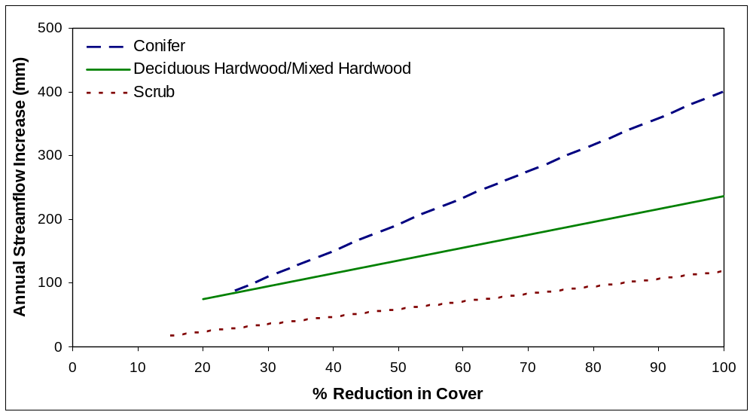
Figure 1. The relationships between reductions in vegetation cover and increases in streamflow for three vegetation types (redrawn from Bosch and Hewlett 1982).

Vegetation management prescriptions that focus on reducing forest-fuel loading and improving forest health might provide measurable changes in the quantity and timing of water draining to streams. The severity and extent of the treatment controls the opportunity to generate a measurable response.

In the case of a fuels management activity, the hydrologic impact is relatively small because only a portion of the forest canopy is usually removed. As noted earlier, usually at least 20 percent of the basal area in a forested watershed above the point of streamflow measurement must be removed to reliably generate a measurable change in water yield. As the point of measurement moves downstream from the treated area and relative watershed size increases, it becomes unlikely that forest management activities will affect 20 percent or more of the total basal area above the point of measurement. A change in water yield that occurs on-site in response to treatment is progressively less likely to be detected downstream (Harr 1983). For example, patch clear cutting 36 percent of the North Fork of Deadhorse Creek sub basin in central Colorado resulted in a significant increase in streamflow from that drainage (Troendle and King 1987). However, the change in flow that was detectable at the stream gauge just below the treatment area was not detectable a few hundred yards downstream at the stream gauge located below the confluence with the main stem of Deadhorse creek. Removing 36 percent of the basal area on the 100 acre North Fork sub drainage represented only a 5.6 percent reduction in the total basal area above the main stream gauge on the 640 acre Deadhorse Creek watershed. Although the change in water yield documented on-site as it exited the North Fork sub drainage was not detectable off-site, the increase in water yield was likely present in the measured flow at the main stream gauge (Troendle and King 1987), just not detectable.

A hydrologic change due to a partial reduction in the forest canopy can be short term except in the snow zone. In that zone, vegetation growth is slowed and reductions in interception loss contribute to a long-term change in water yield. Extrapolation of streamflow records from the Oregon Cascades suggested that annual water yields in Douglas-fir would return to pretreatment conditions 27 years after timber harvesting (Harr 1983) and approximately 24 years are required for a similar recovery in the Coastal Range of Oregon (Harr 1983; Stednick and Kern 1992). This would imply a quicker recovery than observed in the cold snow zone of the central Rockies but a less rapid recovery than observed in the central and northern Appalachians ( Hornbeck et al. 1993).

Because most fuels management activities are not designed to be particularly intrusive or widespread, measurement or detection of any increases in water yield can be difficult unless monitoring protocols are designed to be specific to the magnitude of change that might occur. However, changes in water yield that do not exceed measurement error do occur (Bosch and Hewlett 1982) and modeling is perhaps the best approach to assess these changes on- and off-site. Site-specific monitoring to detect on-site impacts is climate dependant, time consuming, and ultimately, too costly to be done at the project level. Operationally, it is most practical to model response and depend on either case studies, as referenced above, or existing monitoring sites to validate on-site responses and provide credibility to the off-site simulations.

Results

The Model

Initially, implementation of the WRENSS Hydrologic Model (WRENSS) procedures was accomplished using manual calculations. Since 1980, several attempts have been made to develop main frame and desk top computer programs to facilitate implementation of the procedures. However, with the exception of modifications proposed by Troendle and Nankervis (2000) and Troendle et al. (2003), little has changed in the empirical components to predict change in water available for stream-flow since 1980.

Dr. Robert Swanson, formerly with Environment Canada, developed an HP-BASIC program to implement portions of WRENSS procedure that Bernier (1986) later reprogrammed in FORTRAN-77. As the capability of personal computers improved, Swanson (1991) produced an MSDOS Windows version of the procedure that was widely used in the United States and Canada (e.g., Shepperd et al. 1991; Troendle and Nankervis 2000). As a result of the recent modifications made in the empirical relationships or technical components developed for use in the original WRENSS, a Microsoft Access version of WRENSS programmed in Microsoft Visual Basic for Application was developed (Swanson 2004) and used in this effort. Computationally, the current model is the same as that used by Troendle et al. (2003).

WRENSS originally focused on predicting change in water yield, or water available for streamflow, which was expected to occur in response to changes in forest cover resulting from silvicultural activities or other forms of vegetation disturbance. Although total water yield from at least the forested portion of the watershed is simulated and evaluated, emphasis in the modeling process is placed on the potential changes in water yield that might occur as the result of past or proposed activities that alter forest composition or density. Grassland areas, water bodies, and other non forested surfaces are usually excluded in the simulations because they function as constants in the modeling process and do not contribute to the estimate of change, only to the estimate of total yield. Validation of model performance was based on the comparison of simulated changes in water yield with actual changes in water yield that were documented based on numerous case studies throughout the United States (Troendle and Leaf 1980).

In the WRENSS procedure, North America is divided into seven distinct hydrologic provinces or regions. The purpose for stratifying North America into seven discrete hydrologic regions was to focus on demonstrated similarities in response within regions and minimize the effect of the variability in land form, climate, and vegetation that occurs between regions. Partitioning the variability of hydrologic response by regional similarities simplified the modeling process and reduced the prediction uncertainty that concerned Hibbert (1967).

For each of the seven hydrologic regions, a series of empirical relationships were developed that allowed partitioning of the components of the water balance for a variety of forest conditions within each region. Regional evapotranspiration modifier coefficients were also presented that allowed adjustments in the primary components in the water balance to account for changes in vegetation density that would result from proposed silvicultural activities. As used in WRENSS, the water balance, or continuity equation, is expressed as:

Streamflow (water yield) =
Precipitation – (Evaporation Loss + Transpiration Loss ⁺ Change in Storage) (1)

Precipitation is in the form of rainfall, snowmelt, or fog drip. Evaporation Loss includes evaporation from the soil and the evaporative losses from the surface of plant canopy and litter (interception loss). Transpiration Loss is the water extracted from the soil and passed through the vegetation back to the atmosphere. Change in Storage includes changes in soil moisture storage and deep seepage to groundwater. Evaporation and Transpiration are usually regarded as losses and reduce the amount of precipitation transformed into streamflow or water available for streamflow. Change in Storage can be important in the short term (i.e., seasonal or less than one year) but in the long term, Change in Storage is assumed to be zero.

Deep seepage is not specifically calculated in the WRENSS procedure. Instead, simulated water yield is considered to be water available for streamflow and includes deep seepage to avoid the complexity of routing water to off-site locations. However, in watersheds with a relatively impervious substrate, the water available for streamflow is usually routed to the stream channel with little loss to deep seepage. In more porous systems, such as karst topography, a larger percentage of the water available for streamflow is lost to deep seepage. In either case, the water-balance calculations identify that portion of precipitation lost as evapotranspiration on-site and that portion of precipitation that is available to become water yield, either directly or indirectly.

During the development/calibration process, the WRENSS simulations of change in water yield resulting from forest disturbance compared well with the treatment responses observed in paired watershed studies (Troendle and Leaf 1980). Although the components of the hydrologic cycle (Equation 1) are always the same, the relative importance of each component can vary considerably with geographic location and from season-to-season, and year-to-year. The complex interaction of climate and vegetation exerts control on the individual components of water balance and the influence that forest disturbance has on the water balance.

Depending on the hydrologic region, water available for streamflow is simulated in a two-step process. First, a site-specific seasonal estimate of the actual evapotranspiration that would occur at full hydrologic use is simulated. The estimate is based on an empirically derived regional relationship between precipitation and potential evapotranspiration for the site. Basically, this step scales the potential evapotranspiration for the site to what could occur given the available precipitation and assuming forest vegetation is fully occupying the site. Second, the estimate of actual evapotranspiration that could occur under full hydrologic use on the site is adjusted to reflect the species present and the density of the forest vegetation.

The specie-specific evapotranspiration-modifier coefficients are used to adjust the evapotranspiration that could occur on the site, given the available energy and precipitation, to what should occur given the current vegetation composition. The coefficients were derived based on experimental observations of the relationship between surrogates for stand density (i.e., basal area, leaf area index, or cover density) and evapotranspiration (Troendle and Leaf 1980). Unfortunately, this relationship is not available for all forest species present in the study area. Evapotranspiration modifier coefficient relationships were available for deciduous forest, Douglas-fir, lodgepole pine, ponderosa pine, and spruce-fir. This limitation required grouping species without known relationships with those with defined relationships. For example, bigleaf maple and tanbark oak were grouped into the deciduous forest class; whitebark pine was grouped into the ponderosa pine while red fir; and white fir were grouped into spruce-fir. There is little likelihood that the grouping process resulted in a significant error in the simulation of changes in water available for streamflow.

In general, at least 10 percent of the initial basal area of a stand fully occupying the site has to be removed before the WRENSS hydrologic Model will simulate that a change in water available for streamflow might occur. Depending on the hydrologic region, the model will simulate that changes in water yield will occur that fall below the level of detection.

Hydrologic Region 7, the Central Sierra Region in the WRENSS Handbook, encompasses the entire study area. The Central Sierra Region is further divided into two hydrologic zones based on precipitation form. One is the Snow Zone lying at or above 4000-feet elevation where a snow-dominated procedure (SDP) is used to model hydrologic response. A rain-dominated procedure (RDP) is used to simulate hydrologic response on forested areas below 4000-feet elevation where precipitation occurs primarily as rain.

The RDP implemented on forest lands in the lower elevation zone is the same procedure as presented in the WRENSS Handbook (U.S. Environmental Protection Agency 1980; Troendle and Leaf 1980; Swanson 2004). The SDP, originally developed for the snow dominated zone in the Central Sierras, is also available for implementation in the updated version of the WRENSS Hydrologic Model (Swanson 2004), but it was not used in this application. Instead, the recently developed Modified Rocky Mountain/Inland Intermountain Region Procedure for WRENSS Hydrologic Region 4 was used (see Troendle and Nankervis 2000; Troendle et al. 2003). We felt that the Modified Rocky Mountain/Inland Intermountain Region procedure addresses the snowpack accumulation and melt processes that occur in the Central Sierra Region more appropriately than the procedures presented in the original version of WRENSS. A preliminary comparison of simulation results using the two procedures indicated that the simulated estimates of water available for streamflow and the change in water yield resulting from vegetation modification were comparable using either the original or modified procedure. Since current thinking on process definitions for the cold snow zone of the Rocky Mountains/ Inland Intermountain Region (Stednick and Troendle 2004) and the warm snow zone of the Central Sierra Region (Kattleman and Ice 2004) are better represented in the Modified Rocky Mountain/Inland Intermountain Procedure, we made the decision to rely on the modified procedure.

Dataset

As noted, the initial scope of the project was to simulate the hydrologic impacts of the forest management activities on the majority of the 2.5-million acre HFQLG project area. However, it was quickly determined that the stand descriptions, or vegetation data, required for the hydrologic simulations were not readily available for the Lassen and Tahoe National Forests. Since data was only available for the Plumas National Forest the study area was reduced to five HUC-5 watersheds that occupy approximately 412,000 acres (Figure 2, Table 1). Data describing current forest condition on the HUC-5 watersheds was provided by Forest Service staff and was derived from the Vestra Resources PLAS Vegetation Map. A GIS layer of the study area was provided that divided the watersheds into a series of polygons, each with a uniform cover. Uniform cover implies that the polygon, regardless of aerial extent, has a uniform vegetation class (forest, shrub, grass, and non forest), vegetation type (forest, grass, bare ground, water, rock, urban, etc.), specie composition (18 tree species, 19 brush species), size class (0-6), canopy cover, land use, wetland type, and large-tree crown characteristic.

Although extensive, the polygon attributes did not include a metric describing basal area per acre of the forest stand. This is a driving variable in the version of WRENSS used in the SDP applied to the Central Sierra Region. The Forest Service staff assisted in converting the crown density/spacing data for polygons containing forest vegetation to an estimate of basal area per acre. Error estimates associated with the conversions were unavailable and, although any conversion errors would impact the simulation of total water yield, they would have a minor impact on the simulations of change in water yield resulting from disturbance. Basal area estimates are critical in defining existing conditions and baseline water yield, but the simulation of change in water yield is more strongly related to the percentage change in basal area, not the actual basal area. Polygons that were not forested (grass, bare ground, water, rock, shrub, etc.) were eliminated from further analysis.

The GIS layer describing forested polygons was intersected with a GIS topographic map to determine aspect and a GIS map of monthly precipitation to determine monthly and seasonal precipitation. The overlay procedure created a new, composite GIS map depicting the logical combinations of forest-stand polygons each having a uniform vegetation cover, aspect, and seasonal precipitation. The definition of aspect consisted of assigning one of the four cardinal directions to each polygon. In a subsequent lumping process, an east or west aspect designation was considered similar in the modeling process (Troendle and Leaf 1980). Monthly precipitation was determined by intersecting the vegetation layer with the Oregon State climatic map for California. The intersection process caused the number of unique polygons to increase dramatically.

The resulting data set consisted of approximately 95,000 unique polygons that varied in size from less than 1 acre to approximately 95 acres. For the simulations, however, like polygons (those that had similar species and size class, basal area, aspect, seasonal precipitation, and elevation zone) were aggregated to reduce sample size and simplify or expedite various aspects of the modeling process. The land cover and spatial resolution of the forested environment, as depicted in this study, contrasted significantly from the coarse 1-km² grid used by Huff et al. (1999) in an earlier analysis. As mentioned, all non forest polygons were dropped from analysis, which reduced the study area from approximately 412,000 acres to approximately 363,000 acres of forest land (Tables 1 and 2).

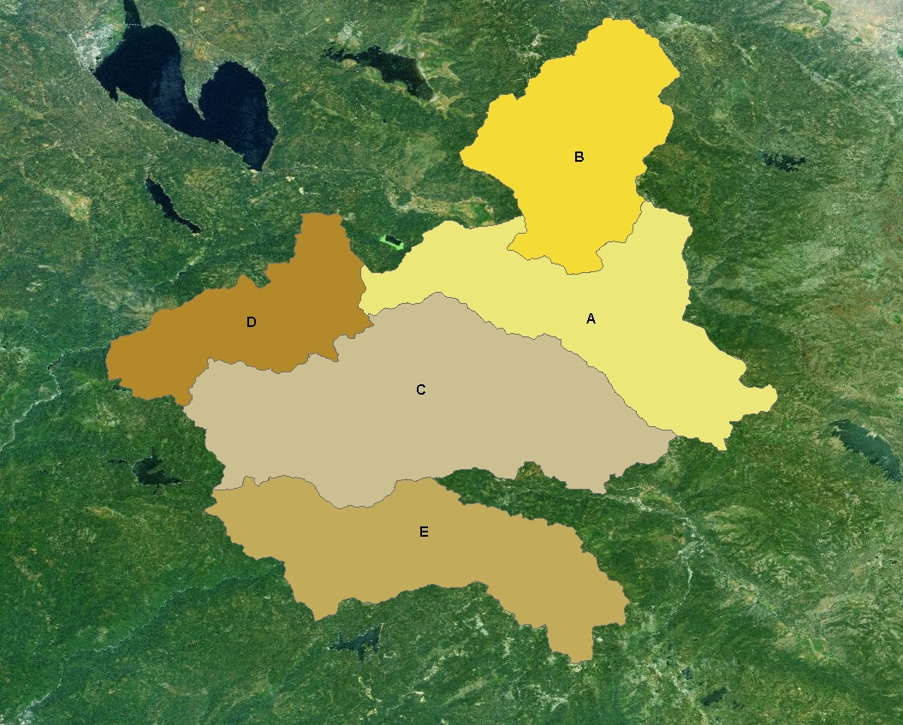

Figure 2. Map showing the general location and proximity of the five HUC-5 watersheds in the study area on the Plumas National Forest.

A satellite image of the study area provides some insight into the location of the forested area relative to the open meadows or grass land, brush land, rock, bare areas, and water surfaces that have been excluded from further analysis (Figure 3). Approximately 88-percent of the area in the five HUC-5 watersheds is forested while 12 percent is classed as non forested. Any polygons characterized as deforested, in contrast to non forest, are included in the forest database.

Table 1. Characteristics of the five HUC-5 watersheds used in the study. Estimates of area include forested and non forested lands within each watershed although hydrologic simulations were made for only the forested portions of each watershed. The total area of the five watersheds in Table 1 is 412,486 acres, of which 363,392 acres are forested.

HUC Identifier Map Symbol | HUC-5 Name | HUC-5 Identification Number | Area  (Acres)
A | Lower Indian Creek | 1802012204 | 84,826
B | Lights Creek | 1802012205 | 67,480
C | Spanish Creek | 1802012207 | 129,565
D | Lower East Branch North Fork Feather River | 1802012208 | 49,294
E | Nelson/Onion Valley | 1802012304 | 81,322

In addition to the data layer describing the vegetative land cover, a second layer showing the occurrence, location, and nature of the fuel-reduction treatments that have been or will be implemented on the watersheds from 2000 to 2005 was also provided. This layer showed the year and location where the treatments would be implemented and a description of the silvicultural prescription that would be imposed. All of the treatments involved harvesting only a percentage of the current basal area of the forest stand. In most instances, the stand prescriptions called for leaving 80 to 90 percent of the initial basal area on-site implying that only 10 to 20 percent of the basal area would be removed regardless of initial stand density. In no instance was more than 50 percent of the basal area of the entire polygon proposed for removal. Since the treatment data was provided in a spatial format compatible with the forest-stand data, the treatment polygons were intersected with the vegetation layer and the pre and post treatment stand-basal area was calculated. Often, the proposed activity polygons intersected more than one vegetation polygon and the uniqueness of the smallest uniform polygon was maintained in the GIS, again causing the number of polygons to increase. Sometimes, the polygons showing future treatments intersected polygons treated in a previous year. When this occurred, the resulting polygons characterized the cumulative impact of all treatments.

Simulating the changes in water yield that would result from the proposed treatments involved simulating the water yield for each polygon for both a pre and a post treatment condition with the difference in simulated response representing the change in water yield that occurred as a result of the treatment. Figure 4 shows the location of the proposed treatments in each of the five HUC-5 watersheds. The treatments, as illustrated, represent a small percentage of the total watershed area and are not spatially well distributed either within or between the five watersheds.

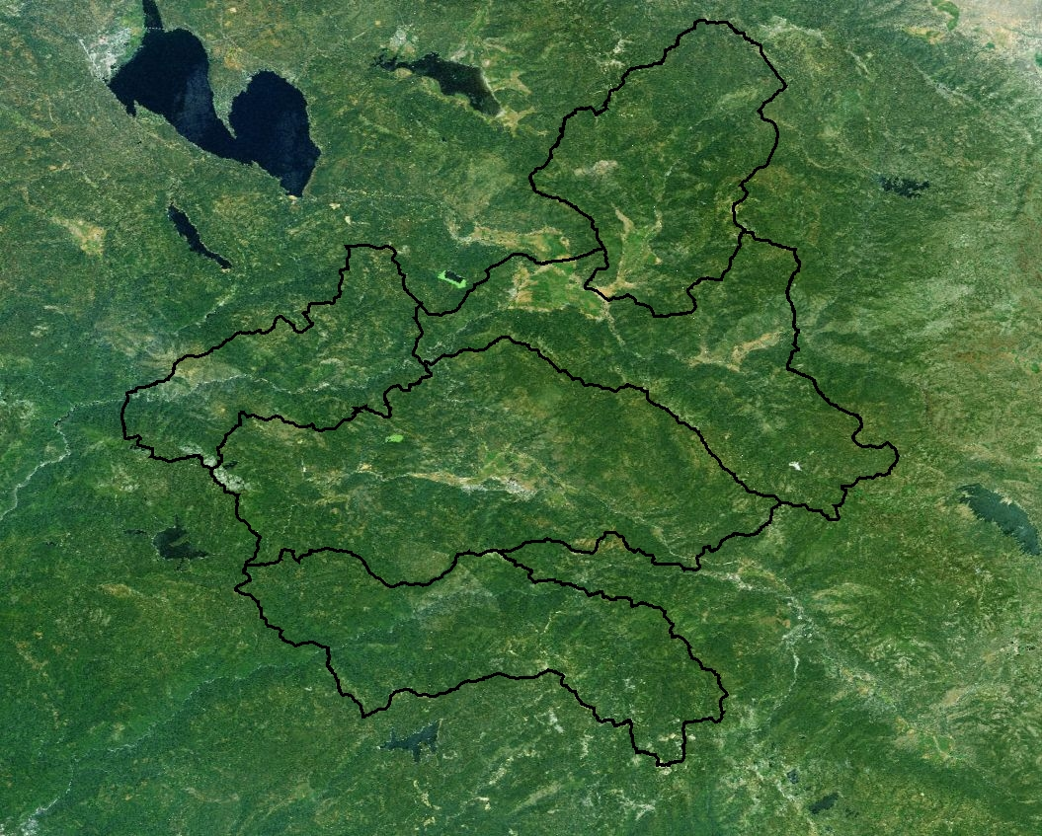

Figure 3. Study area showing the five HUC-5 watershed boundaries. Note the location of non forested areas such as meadows, brush, rock outcrops and bare areas, and water.

Table 2.The acreage of forested area in each of the five HUC-5 watersheds and the acreage of forested area treated or proposed for treatment from 2000 to 2005. The rain-dominated procedure (RDP) represents the portion of the forested area below 4000 feet and the snow-dominate procedure (SDP) represents the portion of the forested area at or above 4000 feet.

HUC | Watershed (HUC) Area (Acres) |  |  | Area Treated  (Acres) |  |  | Percent of Area Treated
HUC | RDP | SDP | Total | RDP | SDP | Total | RDP | SDP | Average
A  1802012204 | 8,680 | 63,410 | 72,090 | 12 | 1126 | 1138 | 0.1 | 1.8 | 1.6
B  1802012205 | 4,146 | 57,728 | 61,874 | 8 | 322 | 330 | 0.2 | 0.6 | 0.5
C  1802012207 | 20,192 | 95,505 | 115,697 | 960 | 6,280 | 7,240 | 4.8 | 6.6 | 6.3
D  1802012208 | 11,121 | 31,454 | 42,575 | 0 | 1,407 | 1,407 | 0 | 4.4 | 3.3
E  1802012304 | 4,463 | 66,693 | 71,156 | 0 | 3,289 | 3,289 | 0 | 4.9 | 4.6
Total Area | 48,603 | 314,789 | 363,392 | 980 | 12,423 | 13,403 | 2.0 | 4.0 | 3.7

Water Yield

The simulation of water yield and the simulations of changes in water yield were executed at the scale of the individual polygon. As noted, similar polygons were aggregated where possible to reduce the number of computations, but their integrity was not lost. Simulated responses, by polygon, were aggregated first by precipitation zone (RDP or SDP) and then by watershed. On average, 87 percent of the approximately 363,000 acres of forested area in the five watersheds occurs at or above 4000 feet. For this area, the Modified Rocky Mountain/ Inland Intermountain procedure was used for simulation. Only 13 percent of the study area lies below 4000 feet and the Central Sierra Rain Dominated Procedure was used to simulate hydrologic response for this area. Within the two forest zones, only 2 percent of the forest area in the RDP zone and 4 percent of the forest area in the SDP zone was proposed for treatment from 2000 to 2005 (Figure 4 and Table 2). Spanish Creek (C) and Nelson/Onion Valley (E) have the largest acreage proposed for treatment, while the least impact occurred in Lower Indian Creek (A) and Lights Creek (B) (Table 2). Overall, the intensity of harvest averaged only 3.7 percent of the forested portion of the study area. Based on the review of past research, a measurable increase in water yield exiting any of the five watersheds would be unlikely. However, as the simulation results demonstrated, this does not imply a change in water yield will not occur.

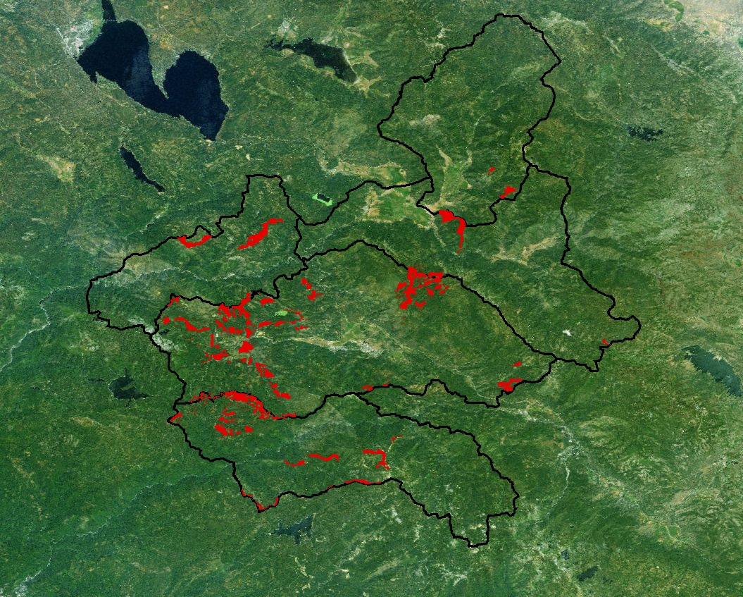

Figure 4. Location of all implemented and proposed fuel reduction activities in the five HUC-5 watershed study areas from 2000 to 2005.

The 30-year average-annual precipitation for the five HUC-5 watersheds, as estimated from the Oregon State University Climate map for California, is 47 inches. Annual precipitation for the rain-dominated area below 4000 feet on the five watersheds averages 44.4 inches. The snow-dominated portion of the watershed at or above 4000 feet receives an average of 47.4 inches of precipitation. Precipitation generally increases with elevation, as was observed on the study watersheds. Although annual precipitation would appear to be more than adequate to meet annual evapotranspiration demands, it is not well distributed throughout the year, therefore seasonal deficiencies occur. January is the wettest month with an average of about 9 inches of precipitation falling on the study area. July is the driest month and receives an average of about 0.25 inches of rainfall. This would imply that the study area is energy limiting in the winter time and water limiting in the summer. Energy limiting occurs when the available precipitation exceeds the potential evaporative capacity and the excess precipitation is stored on the ground as snow, in the soil as soil moisture, or runs off either as deep seepage or streamflow. Water limiting occurs when the evaporative demand exceeds the amount of precipitation available and potential evaporative demands are either not met, soil moisture stores are depleted to meet evaporative demands, or both. The balance between periods of water and energy excesses or limitations control when and how much water yield occurs and affects the degree to which water yield can be altered by vegetation modification. The study area is wet in winter and dry in summer therefore, following forest disturbance, the magnitude and the timing of water yield and the magnitude, timing, and perhaps longevity of water-yield changes are affected.

The average water yield simulated to occur from the five HUC-5 watersheds under existing, or baseline, condition is 28.8 inches (Table 3). The baseline evapotranspiration simulated to occur across the forested portion of all five HUC-5 watersheds is 18.2 inches (47.0 inches of average precipitation - 28.8 inches of water yield). In contrast, the simulated average-annual evapotranspiration for the low-elevation rain-dominated area is 34.4 inches (44.1 inches average precipitation - 9.7 inches water yield) and for the forested portion above 4000 feet, evapotranspiration averages 15.7 inches (47.4 inches average precipitation - 31.7 inches of water yield).

Although water yield averages 28.8 inches across the entire study area, there is significant variability between the five watersheds (Table 3). Simulated water yield varies from a low of 19 inches from the Lights Creek (B) watershed to a high of more than 44 inches from the Nelson/Onion Valley (E) watershed (Table 3). In addition, water yield generated from the low elevation rain dominated portions of the watershed is less but more variable between watersheds than water yields from the higher elevation snow dominated portion of the watersheds (Table 3). The significant increase in runoff and corresponding decrease in evapotranspiration that occurs with increasing elevation reflects differences that exist in the seasonal availability of water and energy that exist between low and high elevations.

There are no paired watershed case studies in the project area to which the simulation results can be compared. However, four USGS stream gauges in the Sierra were identified that had the combination of a long-term streamflow record and no history of diversion. Although the gauging stations selected are distant from the study area, there are enough regional similarities to allow for comparison of the measured water yield and estimated precipitation for the gauged watersheds with the simulations for the study area watersheds, at least for base line precipitation/water yield comparisons. Sagehen Creek (10343500), General Creek (10336645), Blackwood Creek (10336660), and Ward Creek (10336674) are all USGS stream gauges that are at or above 6000 feet. The gauge history for each watershed indicates there are no diversions above any of the gauge sites. Using the published latitude and longitude for each stream gauge, the site was located on the appropriate digital topographic map and the watershed boundary above the stream gauge determined using the GIS. The GIS layer for watershed boundary was then intersected with the Oregon State University Climate Center precipitation map to calculate the area-weighted annual precipitation for each of the four USGS gauged watersheds.

Based on the published streamflow record, long-term average-annual water yield from the four USGS gauged watersheds is 33.5 area inches per year and varies from16 inches on the Sagehen Creek watershed to 46 inches on the Ward Creek watershed. The overall average-annual water yield and the variability in average-annual water yield between the gauged watersheds are comparable to the simulated values from the five HUC-5 study watersheds.

The 30-year average-annual precipitation for the four USGS gauged watersheds, derived by intersecting the watershed boundary with the Oregon State University Climate Center precipitation map, is estimated at 49.8 inches. As with measured streamflow, average-annual precipitation also varies significantly between the four USGS watersheds from a low of 42 inches on the Sagehen Creek watershed to a high of more than 62 inches on Ward Creek watershed. The estimate of evapotranspiration (estimated precipitation – measured water yield) averages 16.5 inches for the four gauged watersheds. As was the case for measured streamflow and estimated precipitation, there is considerable variability in the estimate of annual evapotranspiration on the four individual watersheds.

In comparison, the simulated water balance for the snow zone portion of the five HUC-5 watersheds is close to the water balance estimated for the four USGS gauged watersheds. Average-annual precipitation for the four USGS watersheds is estimated to be 49.8 inches, while it is estimated at 47.4 inches for the five study watersheds. Measured average-annual water yield for the four USGS watersheds is 33.5 inches, while the simulated water yield from the five HUC-5 watersheds is 31.7 inches (Table 3). The estimate of average-annual evapotranspiration for the four USGS watersheds is 16.5 inches, while it is simulated at 15.7 inches for the high elevation portion of the five study watersheds. The variability in precipitation and water yield between the four gauged watersheds and between the five study watersheds is also equally comparable. In general, the baseline simulations of water yield on the study area and the resultant water balance calculations compared well with the limited measured data that is available. This finding is particularly encouraging because no calibration occurred in the application of the WRENSS Hydrologic Model.

Once the baseline water yield was simulated for the five HUC-5 watersheds, the effect of the proposed treatments was simulated (Table 3). On average, water yield from the five HUC-5 watersheds is estimated to increase an equivalent of 0.04 inches, or less than 1 percent, within the entire watershed area in response to the proposed treatments. The percentage of forested area impacted (3.7 percent of the total) and the reduction in basal area on the area impacted (less than 20 percent of basal area removed on the 3.7 percent of the total area treated) are too small to generate a greater increase in water yield at the level of the HUC-5 watershed (Tables 2 and 3). The variation in water-yield increases that were simulated to occur for each of the five HUC-5 watersheds is mostly a reflection of the difference in area treated between the watersheds. In the case of Lower Indian Creek (A) and Lights Creek (B), the simulated change in water yield is too small to report at the watershed level. The increase in water yield at Spanish Creek (C) and Nelson/Onion Valley (E) is 0.07 and 0.06 inches, respectively (Table 3). In general, the contribution to the water-yield increase at the watershed level was greatest from the SDP zone, again primarily because a greater percentage of that area is proposed for treatment relative to the area that will be treated in the lower elevation zone (RDP).

Table 3. Simulated water yield from the forested portion of each of the five HUC-5 watersheds in the study area and the area weighted change in water yield simulated to occur as a result of the fuel reduction harvesting treatments. Note that the change in yield is expressed as an area weighted increase in water yield over the entire forested area.

HUC | Water Yield From Forested Portion of the HUC (Area Inches)
 | Baseline Water Yield (Year 2000) |  |  | Change from Baseline (Year 2005)
 | RDP | SDP | Average | RDP | SDP | Average
A  1802012204 | 3.7 | 23.9 | 21.5 | *** | 0.01 | 0.01
B  1802012205 | 3.0 | 20.2 | 19.0 | *** | *** | ***
C  1802012207 | 10.6 | 34.9 | 30.7 | 0.05 | 0.07 | 0.07
D  1802012208 | 6.8 | 30.4 | 24.3 | 0 | 0.02 | 0.02
E  1802012304 | 31.0 | 45.1 | 44.2 | 0 | 0.06 | 0.06
Average Water Yield | 9.7 | 31.7 | 28.8 | 0.02 | 0.04 | 0.04
*** The simulated value is too small to present.

In contrast to what appears to occur at the watershed scale, assessing the water-yield increases at the project level presents a somewhat different picture (Table 4). On average, the simulated increase in water yield generated from the treated portions of the forested area on the five HUC-5 watersheds is 1.04 area inches (Table 3). The largest increase in water yield, 1.33 area inches, will occur from the treated area in the Nelson/Onion Valley (E) watershed while the smallest increase, 0.56 area inches will occur from the treatment area within the Lights Creek watershed. These differences in response are largely a reflection of differences in the intensity of harvest within the treated area, not area treated, between the watersheds. The increases in water yield from Lower Indian Creek (A) and Lights Creek (B) that were less than 0.01 area inches were too small to present when expressed as a contribution to total flow from the entire watershed area (Table 3), However they are quite comparable with responses from the other watersheds when presented as an on-site increase (Table 4). The hydrologic model simulates that even the 12-acre treatment in the RDP of Indian Creek has the potential for altering water yield on-site or at the level of the 12-acre treated area. Also, increases in water yield from the lower-elevation rain dominated and higher-elevation snow dominated areas are similar when the changes in water yield are allocated to the area treated. The water-yield increases represent a 1,164 acre-foot increase in annual water yield (Table 4) as the net result of imposing fuels reduction treatments on 13,403 acres of forest land on the five HUC-5 watersheds.

Even when expressed as an on-site response, it is still unlikely that the proposed treatments will generate a measurable increase in water yield on-site because in most cases, less than 20 percent of the basal area is proposed for removal from the treated areas. However, as Bosch and Hewlett (1982) implied and the simulations would support, increases in water yield following treatment will be present in the channel network even if they are not detectable. In some cases, such as the Nelson/Onion Valley watershed, the increased water yield might be measurable on-site. Unfortunately, the capability to monitor that response is not present.

Because of the distribution of the annual precipitation, the increases in water yield will primarily occur during the winter and spring melt period as an augmentation to the precipitation or snow melt runoff. Summer flows are unlikely to be affected because of the dry conditions. It is most unlikely that neither the highest peak flows nor the smaller summer storm responses will be affected by treatment.

The HFQLG-project alternatives propose to implement fuels reduction treatments on 200,000 to 300,000 acres of forest. Such treatments, if implemented in a manner similar to those proposed for the five HUC-5 watersheds, would annually yield 17,000 to 26,000 acre feet of additional water. Long-term, such a water-yield increase would be a sizeable, even if not measurable, amount of water.

Table 4. Simulated change in water yield expressed as the increase on the treated area. Note that increases too small to present at the watershed scale are presentable as on-site increases.

HUC | Increase In Water Yield From Treated Area  (inches) |  |  | Increase From Treated Area  (acre feet)
HUC | RDP | SDP | Average | Increase From Treated Area  (acre feet)
A  1802012204 | 0.42 | 0.68 | 0.68 | 65
B  1802012205 | 0.61 | 0.55 | 0.56 | 15
C  1802012207 | 0.98 | 1.11 | 1.09 | 660
D  1802012208 | N/A | 0.51 | 0.67 | 60
E  1802012304 | N/A | 1.33 | 1.33 | 363
Average Increase in Water Yield | 0.97 | 1.05 | 1.04 | 1164

As noted earlier, the WRENSS Hydrologic model simulates an estimate of the average change in water available for streamflow that is likely to occur as the result of forest disturbance. Estimating the reliability of that prediction is complex and has both an on- and off-site component. At the project level, the model was tested by simulating average water yield changes for a variety of paired watershed case studies throughout North America and did so to within 20 or 30 percent of the measured value (Troendle and Leaf 1980; Troendle 1983; Shepperd et al. 1991; and Troendle and Bevenger 1995). However, it can be expected that the change in water available for streamflow that might actually occur in any given year is variable, primarily dependant on actual precipitation amount and distribution, and probably not well represented by the simulated average. In a hydrologic regime, such as the Sierra, the change in water yield that might occur in any given year across the range in proposed treatments could vary from 0 or no effect in drier than average years to several times the simulated response in wet years. In addition, subtle differences in site-specific characteristics such as soil depth or stand structure and diversity that are not well addressed in the model and could add further uncertainty to the simulations at the level of the hill slope or project. However, the accumulation of predictions of the average response from a number of projects can be expected to have considerably less uncertainty because site-specific differences should average out as additional sites are added to the assessment. The estimate of an average increase in water yield of 1164-acre feet from the entire study area (Table 4) is a more reliable number, for example, than the estimate of a 15-acre foot increase in yield from Lights Creek. As the number of treatments increase, the unaccounted variability in the prediction process tends to balance out. There was no indication in model development and testing that there are any particular biases in the regional procedures (Troendle and Leaf 1980). The bottom line is that although the simulated change in water yield is the most likely response that can be expected to occur it is one that will never actually occur, except on-average over the long-term.

Summary and Discussion

Based on the simulations, and supported by the findings of more than 100 years of hydrology research, water-yield increases will occur following the proposed fuel reduction treatments but those increases will be difficult to document in the stream channel. Some of the simulated increases are large enough to be measured on-site or nearby, but the infrastructure to do so is not in place. The dilemma is a function of natural variability in streamflow. Unless 20 percent or more of the basal area of forest vegetation in the watershed above the point of measurement is impacted, the natural variability in streamflow will most likely make detection of any change in water yield difficult to detect. In addition, the infrastructure needed to measure and document change is costly to install and operate and the variability in streamflow dictates that long periods of record are needed to document change.

Streamflow varies seasonally and annually for a variety of reasons. In the short term, (i.e., years to decades) the variability in seasonal and annual water yield is strongly related to temporal and spatial variability in climate. At the landscape level, the potential changes in the water balance expected to occur as a result of vegetation changes are often minor, relative to the consequences of the seasonal and annual variability in precipitation and energy, therefore, detecting the expected change is difficult. However one can infer, from the relationships presented in Figure 1 that water-yield increases will occur in response to even relatively small reductions in vegetation cover. Hydrologic response to forest disturbance occurs before the level of change detection has been reached. As implied in Figure 1, the effect of vegetation disturbance on water yield tends to go to zero as the treatment level approaches zero. The numbers of well documented case studies, both paired watershed experiments and plot and process studies, support this conclusion. Paired watershed studies have been invaluable in documenting the cause and effect relationship between vegetation manipulation and water yield. From a scientific standpoint, our understanding is based on statistically significant responses; thus, the conclusion that a 20 percent reduction in cover is needed to generate a statistically significant change in water yield. However, plot and process studies have helped fill the knowledge gap in understanding what happens when the 20 percent threshold has not been exceeded.

Modeling simulates responses observed to occur in the myriad of case studies and then permits extrapolation from what has been verified to occur in an experimental, or documented, environment to what can be expected to occur under other applications or environmental circumstances. WRENSS is a model that portrays the components and the dynamics of water balance. The model partitions the specific roles that vegetation, precipitation, and energy play in streamflow generation. Increases in water available for streamflow following implementation of fuel reduction treatments will most likely occur. In wet years, increases in streamflow are likely to be greater than the average simulated while in dry years the increases might be non existent. In general, any changes will likely be associated with the dominant runoff periods. The simulations also indicate that similar cumulative water-yield increases if the fuel reduction treatments are implemented will occur in almost direct proportion to the percentage of area treated, assuming a similar intensity of harvest to that proposed for the five HUC-5 watersheds.

The GIS demonstrated that the effects of the proposed treatments on water yield can be assessed at virtually any hydrologic scale of interest, from the project level to the HUC-5 level or to the entire Feather River Basin, depending on appropriateness. As was observed by Huff et al. (2000), Harr (1983), and others, the ability to detect changes in water yield in the stream channel is a function of the scale. Scale includes both the extent and severity of the treatment as well as the relative location of the monitoring point. However, the simulations tend to mitigate those problems and can address change at both the project level as well as off-site. Hydrologic simulations have indicated that the proposed fuel reduction treatments will result in subtle increases in flow at the project level and can account for the translation of those increases downstream.

The proposed fuel reduction treatments will generate increases in streamflow in relative proportion to the intensity of harvest. Because the treatments are largely a thinning of the forest, response will be short lived and perhaps only 15 years. However, an active management program, if perpetuated over time, will result in subtle increases in water yield.

Literature Cited

Bernier, P. Y. 1986. A programmed procedure for evaluating the effect of forest management on water yield. Forestry Management Note No. 37, Northern Forestry Center, Canadian Forestry Service, Edmonton, Alberta.

Bosch, J. M. and J. D. Hewlett. 1982. A review of catchment experiments to determine the effect of vegetation changes on water yield and evapotranspiration. Journal of Hydrology. 55: 2-23.
Harr, R. D. 1983. Potential for augmenting water yield through forest practices in western Washington and western Oregon. Water Resources Bulletin. 19(3): 383-393.

Hibbert, A. R. 1967. Forest treatment effects on water yield. In: W. E. Sopper and H. W. Lull (eds.), Forest Hydrology. Pergamon, New York, NY. 527-543.
Hornbeck, J. W., M. B. Adams, E. S. Corbett, E. S. Verry, and J. A. Lynch. 1993. Long-term impacts of forest treatments on water yield: a summary for the northeastern USA. Journal of Hydrology 150(1993): 323-344.

Huff, D. D., W. W. Hargrove, and R. L. Graham. 1999. Adaptation of WRENSS-FORTRAN-77 for a GIS Application for Water Yield Changes. Oak Ridge National Laboratory Environmental Sciences Division Publication. Number 4860. March 1999. 39 pp.

Huff D. D., W. W. Hargrove, M. L. Tharp, and R. Graham. 2000. Managing Forests for Water Yield: The Importance of Scale. Journal of Forestry. 98(12): 15-19

Ice, George G. and John D. Stednick, eds. 2004. A Century of Forest and Wildland Watershed Lessons. Society of American Foresters, Bethesda, MD. 287 p.

Kattleman, Rick and George G. Ice. 2004. Dry/Cold, Wet/Warm, and Transient Snow: Regional Differences in Forest Snow Hydrology. Chapter 8. In: A Century of Forest and Wildland Watershed Lessons. George G. Ice and John D Stednick, Eds. Society of American Foresters, Washington DC. (Elsevier Pub.) pp.187-200.

Shepperd, W. D., C. A. Troendle, and C. B. Edminster. 1991. Linking water and growth and yield models to evaluate management alternatives in subalpine ecosystems. In: Proceedings. National Silviculture Workshop, 1991, May 6-9. Cedar City, UT. Gen. Tech. Rep. INT-291. Ogden, UT: U.S. Department of Agriculture, Forest Service, Intermountain Research Station. pp. 42-49.
Stednick, J. D. 1996. Monitoring the effects of timber harvest on annual water yield. Journal of Hydrology. 176: 79-95
Stednick, J.D., and T. J. Kern, 1992. Long term effects of timber harvesting in the Oregon Coast Range: The New Alsea Watershed Study (NAWS). In: Interdisciplinary Approaches to Hydrology and Hydrogeology. American Institute of Hydrology, Smyrna, GA. pp. 502-510.

Stednick, John D. and C. A. Troendle. 2004. Water Yield and Timber Harvesting Practices in the Subalpine Forests of the Central Rocky Mountains. Chapter 7. In: A Century of Forest and Wildland Watershed Lessons. George G. Ice and John D Stednick, Eds. Society of American Foresters, Washington DC. (Elsevier Pub.) pp 165-182.

Swanson, R. H. 1991. WRNSHYD-The WRENSS hydrologic procedures programmed for an IBM PC. Computer program and associated files. Available from P.O. Box 1431, Canmore, Alberta, Canada T0L 0M0.
Swanson, R. H. 2004. The complete WRENSS hydrologic model. Proceedings of the 72nd Western Snow Conference. Richmond, BC.
Troendle, C.A. and R.M. King. 1987. The effect of partial cutting and clearcutting on the Deadhorse Creek watershed. Journal of Hydrology. 90: 145-157.
Troendle, C. A. and C. F. Leaf. 1980. Hydrology. In: An approach to water resource evaluation of non-point silvicultural sources. EPA 60018-80-012. Envir Res. Lab., Athens, GA. pp. III-1 - III-173.

Troendle, C. A. and J. M. Nankervis. 2000. Estimating Additional Water Yield from Changes in Management of National Forests in the North Platte Basin. Final Report submitted to the Platte River Office, Bureau of Reclamation. March 2000. 51 p.

Troendle, C. A., J. M. Nankervis, and L. S. Porth. 2003. The impact of Forest Service Activities on the streamflow regime in the Platte River. Final report submitted to the U. S. Forest Service by MATCOM Corporation. Fort Collins, CO. 50 p. plus appendices.
U.S. Environmental Protection Agency. 1980. An Approach to Water Resources Evaluation of Non-Point Silvicultural Sources. U.S. Environmental Protection Agency. August 1980. EPA-600/8-80-012 Athens, GA.

