Economics of Delay

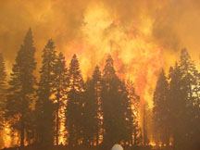Many reasons exist for how long it takes to deal with a catastrophic event. The urgency to determine what can be done after a wildfire begins at a frenzied pace. What to inventory? Who are the key interdisciplinary team members? What are the likely issues? What agencies, groups and individuals will need to be involved? What are the priorities? All these questions are being asked from the first minute. Contributing to this tension is knowing that controversy surrounds every decision and scrutiny will surface before any decisions are made. The clock is ticking, letting you know that the options are diminishing as time marches on.
Figure 1 - STAR FIRE - September 2001

The dilemma that resource managers face when a catastrophic event occurs is enormous. It can be overwhelming to lead the process in a way that the short- and long-term choices are understood and the intent of the most recent land management plan or significant plan amendment like the Sierra Nevada Framework is met, while understanding the concerns of all who are interested in the area.

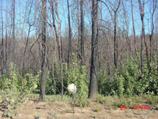Some believe that it is best to remove all the dead trees except those that will contribute to wildlife needs, until they also fall to the ground, and to reforest as soon as possible with a long-term strategy that can be implemented with anticipated funding. Some believe that we should do nothing at all, that we should allow only natural processes to occur, as seen in an untreated area of the 1999 Pendola Fire on the Tahoe National Forest in Figure 2. Others are in between, wanting to manage some of the area to meet long-term goals while also leaving areas to change slowly. Unfortunately, the economics of delay are working against all but those who want to do nothing. Through delay, the ability to implement a decision and the cost of treatments change significantly over time.
Figure 2 – 1999 PENDOLA FIRE -Untreated area two years later

In California, the prevalent conifer species will lose a significant portion of their value for products in a very short time. That potential value is often a significant portion of the funds available to treat the non-merchantable fuels from the dead trees, contribute to the cost of reforestation, or pay for the analysis and documentation of the next catastrophic event through salvage sale trust funds.

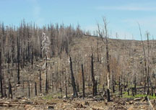GAP FIRE EXPERIENCE

The Gap Fire on Tahoe NF is an example of how options are reduced within the first year after a wildfire. The Gap Fire burned 1,373 acres of National Forest and 1,077 acres of private land in August of 2001. Most of the areas burned on adjacent private land were treated by the end of November 2001 as seen in Figure 3. The Gap Fire Restoration Environmental Assessment for the areas on the Tahoe NF was completed and a decision signed by June 2002. The appeal process began. Only one individual, who openly states that he opposes any commercial harvest on National Forests, appealed the decision. One of his biggest interests was for the Forest Service to remove only the smaller trees, generally those less than 10 inches diameter. The smaller sawtimber-sized dead trees were still merchantable until June 2002. Then, significant deterioration was beginning to set in, and worms and checking that reduce the value were showing up. By September, when the decision was upheld, timber sales were offered to prospective purchasers in hopes that the dead trees were sufficiently valuable to pay for their own removal. The project proposed logging about 80 percent of the area by helicopter due to moderately steep slopes. No bids were received on the timber sales. Delay had caused the value of the trees, due to deterioration, to drop below the cost of removing them with helicopters. The combination of delay to insure that the documentation would sustain appeals or litigation and the delay directly associated with the appeal reduced the project’s economics. The loss in overall value, conservatively estimated at over $400,000 (see Figure 4), changed the ability to meet fuel reduction goals. The lumber that could have been utilized is equivalent to 450 homes at 10,000 board feet each. This does not take into account the high cost of removing this material that is no longer merchantable or the potential effects to the land when the next fire consumes them if money is not available for treatment. Ironically, the appeal, which advocated a fire restoration focus on only the small-sized trees, actually reduced the capacity to accomplish that very action by delaying implementation.
Figure 3 - GAP FIRE – Private land treated within months of the fire (right). Land administered by the Forest Service untreated a year later (upper left)
Figure 4 – Dollars and lumber lost due to delay (10,000 bf per home)

Value Lost

Gap Fire

$ 400,000
Lumber for 450 homes

Star Fire

$ 2,600,000
Lumber for 1,350 homes

Figure 5 displays an estimate of the significant change in fuel reduction over a short time. It shows the difference between removing the smaller trees in time to capture their value as sawtimber, thereby paying for their removal, instead of requiring scarce appropriated funds to do the work. This highlights what happens when the analysis and appeal process takes longer than the time that the trees maintain their value as sawtimber. The amount of money lost due to delays 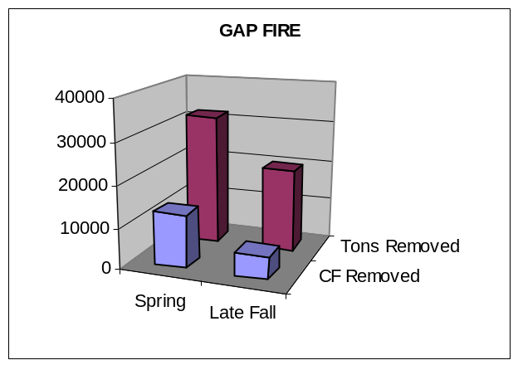could have been used to hand pile over 650 acres of fuels on steep ground or machine pile about 1,000 acres on tractor ground. If restoration work had begun earlier when more material was economical to remove, less fuels would need to be removed later using appropriated funds.
Figure 5 - GAP FIRE - Reduction in fuel treatment in tons and cubic feet over time

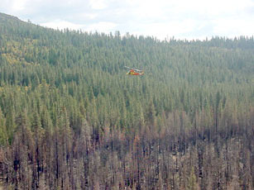
Figure 6 displays the significant fuel loading remaining from the non-merchantable trees after the merchantable trees have been felled and are in the process of being removed by helicopter on the Gap Fire. By the time the appeal resolution period was over, only trees 16 inches and greater in diameter were merchantable. The cost of further reducing the fuels in this area, designated as “Defense Zone” in the land management plan, is very high.

While some suggest that heavy residual fuel loading is acceptable and natural, the fact remains that this high level of woody material left on-site will be a significant fire hazard in the future.
Figure 6 - GAP FIRE – Significant fuels remaining after timber sale due to deterioration

STAR FIRE EXPERIENCE

Another much larger wildfire happened just weeks after the Gap Fire on an adjacent Ranger District of the Tahoe NF. The Star fire burned over 10,473 acres on the Foresthill RD of Tahoe NF and 4,590 acres of private land before being controlled. The complexities associated with this area are significant. The land management plan emphasizes Old Forest for most of this area. The Star Fire area includes Duncan Canyon, an inventoried roadless area, a portion of which is being proposed for wilderness designation and is adjacent to French Meadows Reservoir, a popular recreation area. Several important trails, 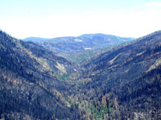including the Western States Trail, lie within the area, where yearly events are held. The Middle Fork of the American River is an important source of irrigation and drinking water for downstream communities.
Figure 7 - STAR FIRE - September 2001

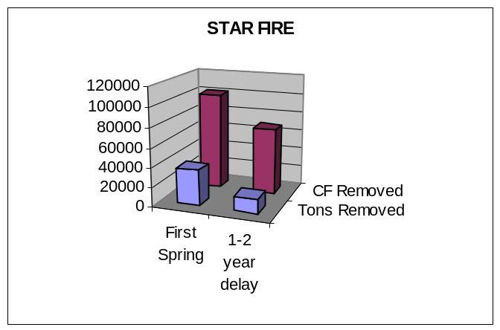Controversy was inevitable. Many agencies, groups, and individuals are interested in decisions affecting the long-term management of this area. During public scoping, over 4,000 written and emailed comments were received about the proposed action. Many of the comments focused on the need to remove the smaller fuels. Over many years, this material can contribute to a new and intense fire if ignited. Anticipating appeals and litigation, much extra effort went into project design, analysis, and documentation. The Red Star Restoration Project’s Record of Decision was approved in November 2002, more than one year after the fire. The best-case scenario now calls for work to begin in June 2003. The time needed to complete inventory and analysis, receive public comments, develop alternatives, and document the record of decision was extensive and the economic loss due to this extended planning process are significant.
Figure 8 - STAR FIRE – Reduction in fuel treatment in tons and cubic feet over time
Figure 8 shows the amount of fuel from dead trees that will not be removed on the Star Fire due to delay. The effects are even more significant than the Gap Fire, because the analysis and appeal process have taken over a year and no harvesting will occur until the second spring after the fire. Costs for removing the fuels from the most critical areas are very high, especially where helicopter yarding is needed (about 85 percent of the project). Due to delay, a much larger amount of the area will not be able to meet desired conditions until appropriated funds can be used. The value lost due to delay on the Star Fire is conservatively estimated at over $2,600,000 (see Figure 4). This amount could have paid to hand pile at least 4,300 acres of fuels on steep terrain and does not account for the cost to treat this material, or other increased costs such as reforestation, that also increased due to delay. In addition, the lumber lost could have built 1,350 homes.

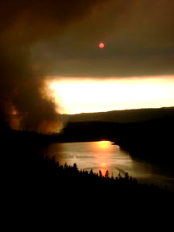How can we reduce the time needed to deal with catastrophic events to minimize the economic effects of delay? How can we ensure that the process will provide a reasonable approach to minimizing soil erosion by providing ground cover available from the smallest of the dead trees before the first winter storms? How can we agree that the long-term goals are just as important as the short-term concerns? Without consensus about the basic approach to restoration of forest ecosystems, or clear direction that recognizes the significant effects of delay when these conditions arise, the process will continue to be exorbitantly expensive. The lack of consensus and its associated delay will diminish the opportunities to utilize dead trees to benefit human needs, lessen future options, and contribute to the increased cost of treating fuels. Those effects are a high concern and reduce our ability to meet long-term objectives for forested land under any land allocation goal. The most significant cost is the loss of the option to react quickly. The costs are extreme once time has passed. Without changes to the process and clear direction for similar conditions, the economics of delay will decide the outcomes for us. Until then, when we see smoke, it will have a significant effect on both the environment and its stewards.
Figure 9 - STAR FIRE view across French Meadows Reservoir

SUMMARY

The cost of delaying implementation of fire restoration projects is both real and significant. The main issue to consider is how to avoid the delay. Some pertinent points and hypotheses to consider are:

- The point of diminishing returns of the quality of restoration planning, including substantive public participation, is normally reached well before the completion of the environmental document. Substantial additional time in the preparation of environmental documents is spent developing the technical aspects of the analysis and document to withstand potential appeals and litigation, with little additional benefit for on-the-ground resources. The point of diminishing returns may come as early as 3 to 4 months into the environmental analysis and documentation process for all but the most complex projects.

- Changes in Forest Service National Environmental Policy Act implementation regulations now being considered may help resolve economic losses and related reductions in resource restoration. As an example, expansion of Categorical Exclusion authority could allow limited removal of some fire-killed trees in the same year as the fire (e.g., helicopter removal of smaller trees on steep slopes in order to produce ground cover from branches, limbs and bark to reduce first-winter erosion). This would ensure that removal of the smaller material is done when it is still economically self-supporting. Another example is the proposed streamlining of the process for requesting an exemption from stay under the 215 appeal regulations for emergency situations.

- Any real and lasting changes in our ability to reduce the cost of delay must ultimately rely on successfully prevailing in court when our project environmental documents are challenged. Because success in court often is more related to technical shortcomings in environmental documentation than to shortcomings in on-the-ground environmental quality, it is an increasingly difficult challenge to overcome. The requirements are continually being changed and the ultimate ruling in court may depend heavily on the personal biases of the judge(s) involved.

